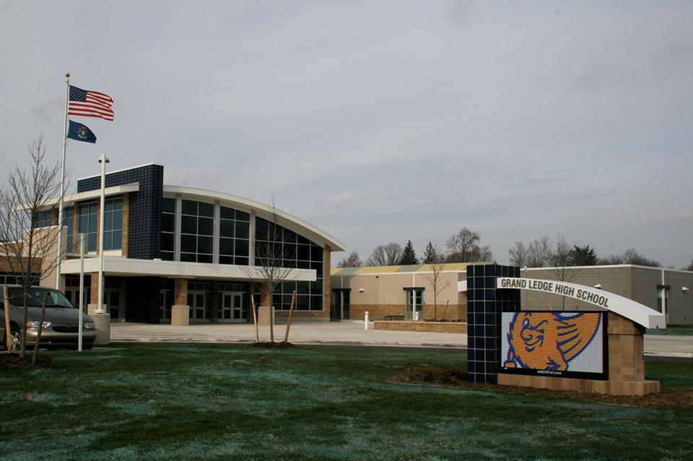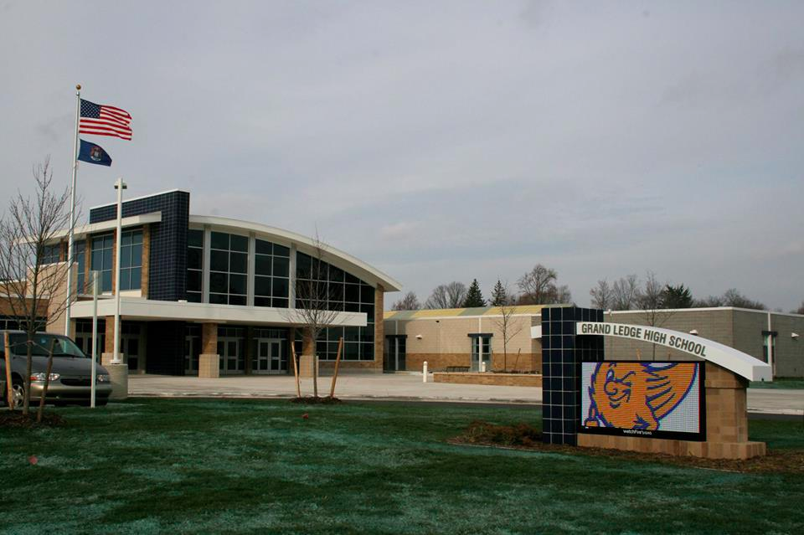

With the start of school in full swing, I would like you to know that I will be your student’s case coordinator for the 2017-2018 school year. For the first few weeks of school, I will be making personal contacts with each student on my caseload and sending out an IEP summary to each of your student’s teachers so they are aware of accommodations and goals. Schedules were set during the summer and most requests have been finalized. Your schedule is set for the remainder of the year.

Please encourage your student to seek me out if there is an immediate problem or need.

If you would like to contact me, I can be reached by e-mail at [hoffmanp@glcomets.net](mailto:boydb@glcomets.net) or by phone at 517-925-5910. E-mail works great for staying in contact, so if you want to send me your e-mail address, I will put it into by address book. Also, if there is anything that you would like to share with me that would help me learn about your student’s strengths and challenges as well as help me determine the level of support that is needed earlier in the year, I would appreciate the information.

Annual IEPs will be scheduled throughout the year; **please make sure your student is in attendance.** Starting in high school, we will really focus on the small steps that need to be taken, supports that need to be established, and academic assistance that is needed to make this transition from high school a smooth and successful one.

The transition plan plays a large role in your students IEP and we will be working this year to develop a solid transition plan and have supports in place for your student’s success. Therefore, the IEP meeting really is an informative and efficient way to plan for each student’s future, and your student is crucial to this process.

Grand LedgE High school

9/1/17 No School

9/4/17 No School

9/22/17 Picture Make up day

9/23/16: 2 hour Early Release

9/29/17: Fall Homecoming

10/4/17: Count Day

10/03/17: Conferences 4- 7:30pm

10/05/17: Conferences 4-7:30pm

10/06/17: ½ Day for Students

10/11/17: PSAT

11/7/17: Picture retake day

11/16 -11/17/17: Final Exams

11/17/17: End of first trimester

11/20 – 11/24: Thanksgiving Recess

#### Trimester 1 Calendar

### Fall 2017

## IEP Meetings and Communication

# Welcome back, Comets!

Many teachers have been hard at work this summer to prepare and update classes. Academic Success class continues to evolve. The purpose of this class is to help you manage your time, your accommodations, and understand your IEP. There is time built into the class for homework help, but please plan for 30 minutes of homework help during the class. We can no longer have a class that focuses only on homework and give an elective credit toward graduation for that class. Curriculum needs to be tied to everything we do.

Grand Ledge High School Special Services Department Staff:

Beth Boyd: [boydb@glcomets.net](mailto:boydb@glcomets.net)

Kassie Davis: [davisk1@glcomets.net](mailto:davisk1@glcomets.net)

Paula Hoffman: [hoffmanp@glcomets.net](mailto:hoffmanp@glcomets.net)

Drew Huard: [huarda@glcomets.net](mailto:huarda@glcomets.net)

Meghan Joseph: [josephm@glcomets.net](mailto:josephm@glcomets.net)

Dave Logel: [logeld@glcomets.net](mailto:logeld@glcomets.net)

Claire Mull: [mullc@glcomets.net](mailto:mullc@glcomets.net)

Gail Schafer: [schaferg@glcomets.net](mailto:schaferg@glcomets.net)

Elena Schreur: [schreur@glcomets.net](mailto:schreur@glcomets.net)

Tomi Simmons: [simmonst@glcomets.net](mailto:simmonst@glcomets.net)

Tracey Smith: [smitht@glcomets.net](mailto:smitht@glcomets.net)

Karl Wood: [woodk@glcomets.net](mailto:woodk@glcomets.net)

**WELCOME TO GLHS!!!**

Elena Schreur (Ms. S): This is her 5th year teaching. She attended Grand Valley State University, where she graduated in 2013 with my BS and teaching certificate with special education endorsements. She is originally from Grand Rapids but moved up to Sault Ste. Marie, MI after graduation to begin her career in education. For the past four years, she taught special education in the Upper Peninsula, while also attending a number of math instruction trainings. She is very excited about the opportunity to teach at Grand Ledge and combine her two greatest passions- teaching math and special education. Please welcome her we are really excited about having her join our special education team.

## Welcome new teachers!

## Important Information

High School ……… 925-5815

FAX……………… 925-5929

Attendance………. 925-5818

Special Services …. 925-5410

Director of Special Services: Ms. Sara Sutherland

Special Education Department Chair: Beth Boyd (517) 925-5906

Follow us on social media:

Grand Ledge High School on Facebook

@glhscomets

#proudtobeacomet

## Update on classes and scheduling